## Configure Word (QRC)

## Introduction

The Configure Word QRC shows how to set up the optimal configuration to utilize the EMAF Word templates on ExxonMobil PCs and storing the Word-based artifacts or deliverables on the EMAF Architecture Repository.

## Configure Word Instructions

### Create **My Templates** Folders

If Configure Visio QRC was not completed: From File Explorer, navigate to your network account **c:\users\<your network id>\LocalData** folder, and a folder called **My Templates**

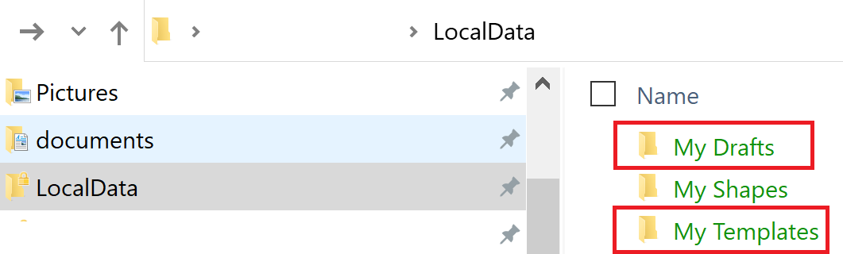

### To configure Word to use **My Shapes** & **My Templates** Folders

1. In Word, click the **File** Menu

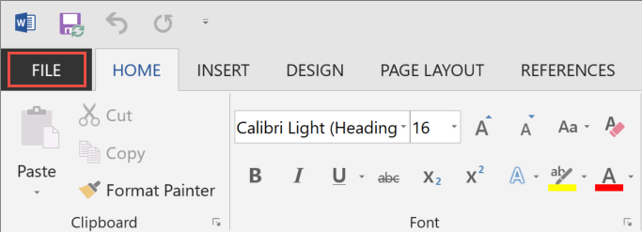

1. Click the **Options** Sub-menu

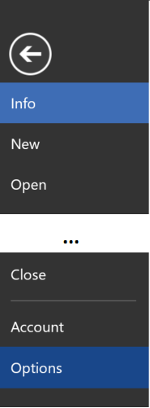

1. Once the Word Option dialog box is displayed
   1. Click the **Advanced** option
   2. Scroll towards bottom and click the **File Locations…** button

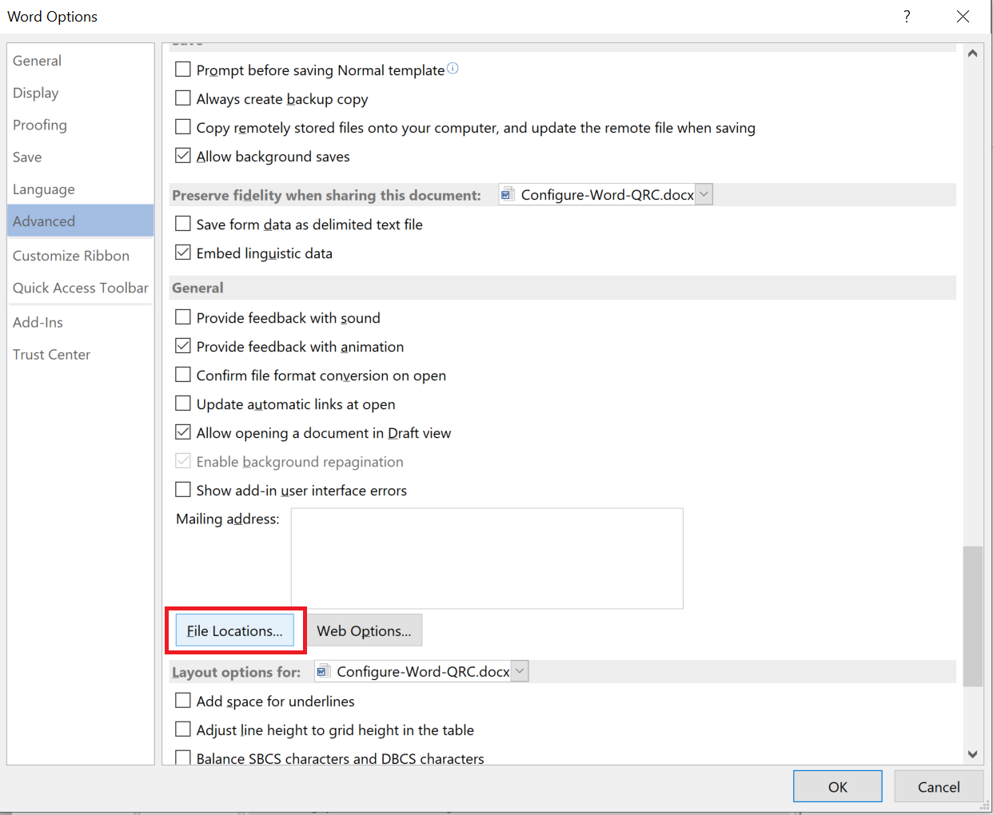

1. Configure the **My Templates** Folders

* Click into the “Workgroup templates”, then click the **Modify** button
* Set the path to your **localdata\My Templates** folder and click the **OK** button
* Click the **OK** button

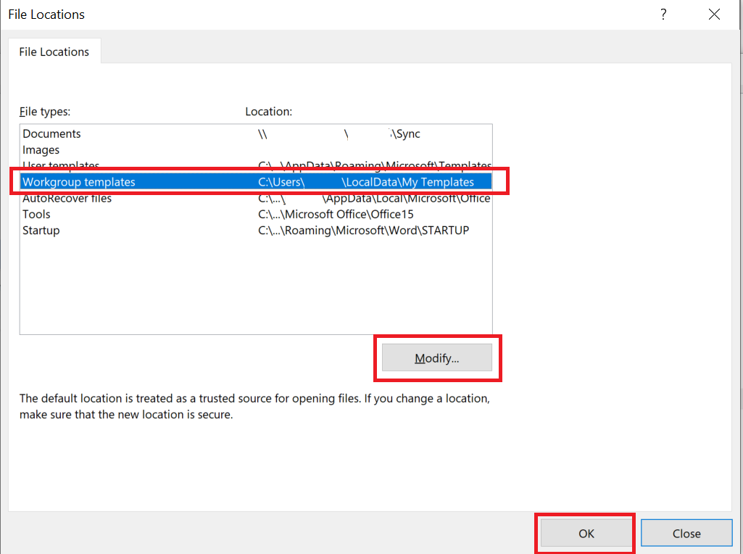

**NOTE: When you create a new artifact (File -> New -> Custom -> My Template), all EMAF templates will be displayed**

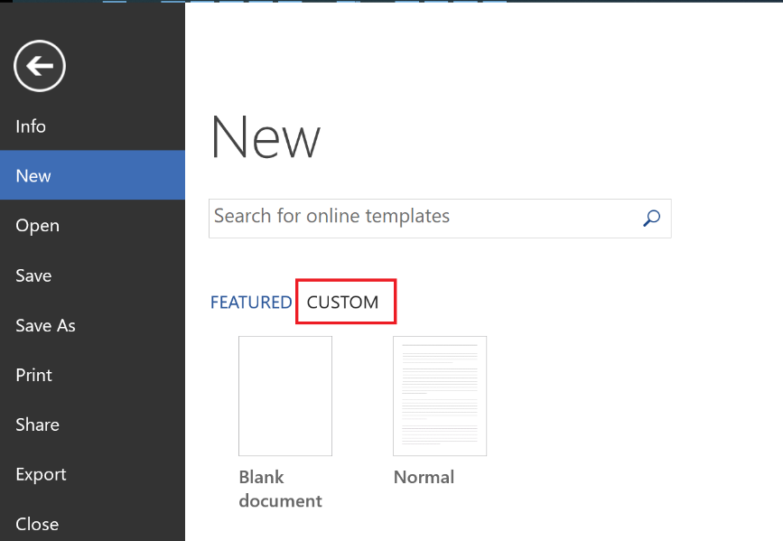

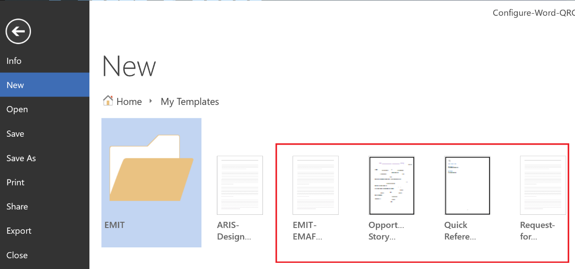

### To pin EMAF Architecture Repository Targets

Once you have begun opening or saving Word documents to folders in the EMAF Architecture Repository, these folders will begin appear under your Recent Folders area which you can then pin these locations for a quick and convenient way to access these locations in the future.

1. In Word, click the **File** Menu



1. Click either the **Open** or **Save As** Sub-menu, click **SharePoint**, then under the **Recent Folder** area select the SharePoint location and click the **Browse** button

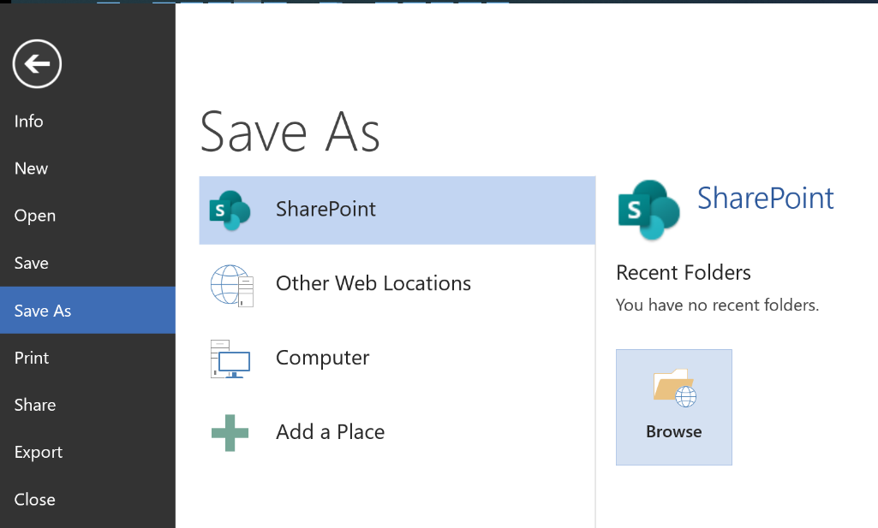

1. Within the Open dialog box

* Copy/paste the following URL into path field: <https://ishareteam4.na.xom.com/sites/Architect/Architecture%20Repository>
* Select the following file: **Use-For-Setting-Up-Word**
* Click the **OK** button

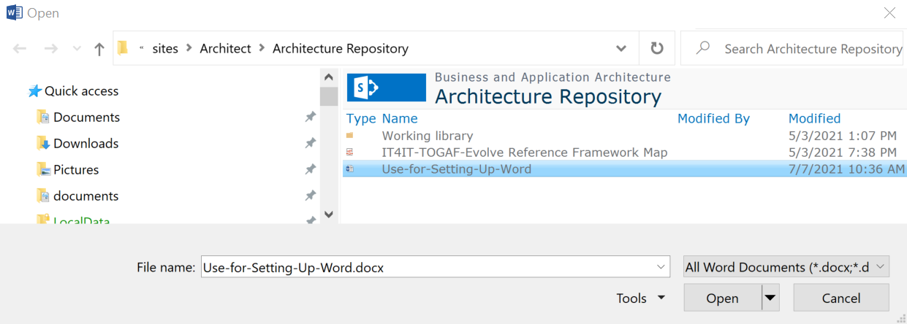

1. Now that the goto/ArchRepo path has been registered within your Word client, perform the following steps

* Navigate to **File -> Open -> SharePoint -> Recent Folders**
* Right mouse click on the **Architecture Repository** entry
* Select **Pin to List** option

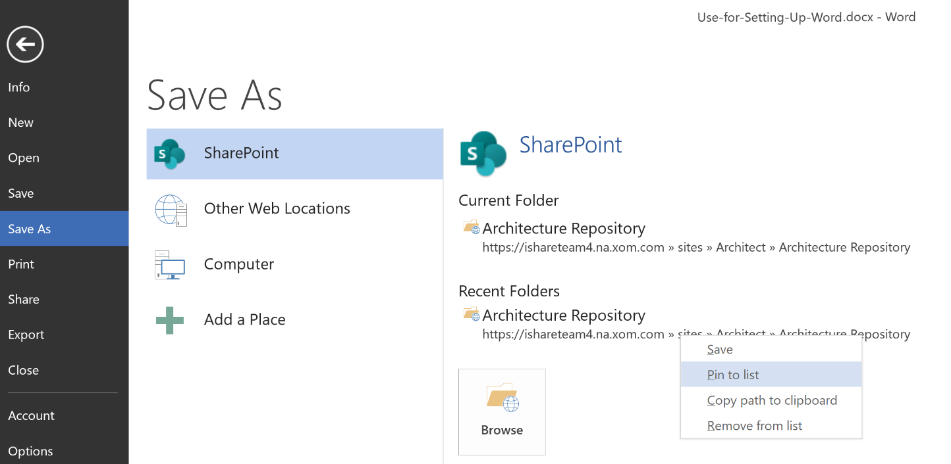

1. To use the pinned locations, simply

* Navigate to **File -> Open -> SharePoint** or **File -> Save As -> SharePoint**
* Click the pinned location you want to use
* Click the Browse Button

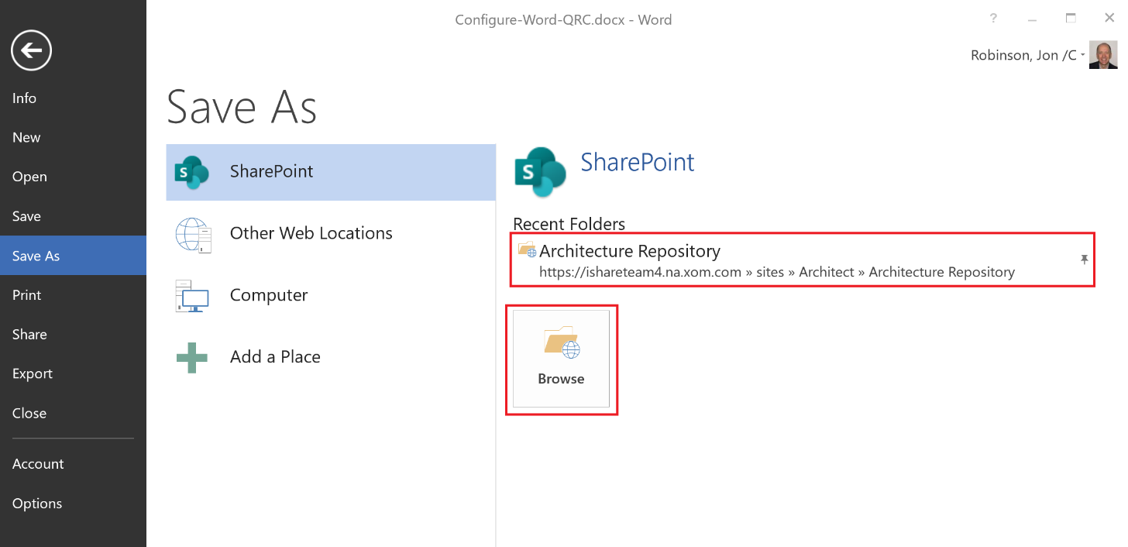

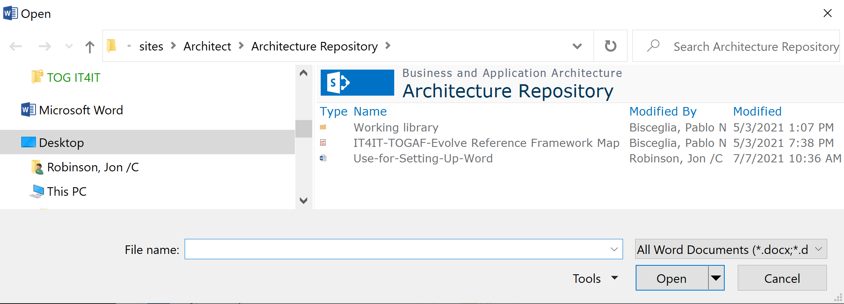

**NOTE: Repeat steps 1-6 for your project / architecture repositories located under Working Library.**